Professor comment:
Great topic and your graph works very well to support your thesis.
However, please refer to the narrative arc structure. What's the backstory? Why are looking for low calorie foods these days?
Is there a conflict? Sugar was hurting people? Sugar was making people overweight? Once you establish that, you have your climax - the hero is sugar substitutes that have taken over the market.
Does that make sense the way I am setting this up? Let me know if not.
I hope these comments help guide your thoughts. I will let you resubmit your work again.

This is the graph from the article you provided me
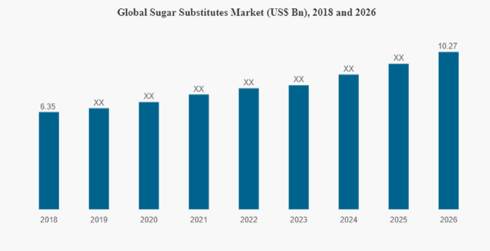

From the instruction: the narrative arc, starting at the beginning, moving towards the climax, and then ending in a resolution.

Narrative arc structure (in picture):

